Complaints procedure template

This is a template for a complaints procedure in line with the Corporate Sustainability Due Diligence Directive including the effectiveness criteria in the UN Guiding Principles. It aligns with the notification mechanism template.
There are two annexes:
- Annex A: Decision tree
- Annex B: Default messages
The decision tree relates to the overlaps in material and personal scopes of the Corporate Sustainability Due Diligence Directive and the Whistleblowing Directive. In the template, there are two alternatives for how to handle these overlaps.
The default messages have been developed as support to coordinators and case managers. They shall be adapted in line with how you adapt the text in the notification mechanism template, depending on alternative mechanisms in each market etc.

Complaints Procedure

1. Purpose
The purpose of this instruction is to establish rules for [Company]’s [group-wide] complaints procedure, including notification mechanisms, for adverse human rights and environmental impacts.
2. Target Groups
2.1 Basic knowledge
The following groups shall have basic knowledge of this instruction:
Employees, consultants and contractors [in staff functions and business areas] working on issues affecting [Company]’s workforce, workers in the value chain, affected communities, consumers and end-users, or the environment.
2.2 Thorough knowledge
The following groups shall have thorough knowledge of this instruction and comply with the roles and responsibilities described herein:
Employees, consultants and contractors [in staff functions and business areas] involved in receiving complaints, verifying complaints, investigating complaints and determining responses, remediating complaints, monitoring the remediation, closing complaints, and/or incorporating feedback and evaluating results.
3. Building Trust
3.1 Notification mechanisms
[Sustainability Department] shall ensure that there is a digital notification mechanism [with an accompanying toll-free hotline] in place.
For each project, Business Areas shall also have the following in place throughout the project lifecycle:
- A phone number (including voicemail and WhatsApp/Signal/Telegram) to an appropriate person. The assigned person shall monitor incoming calls and messages.
- An email address to one or more (if a shared inbox) appropriate person(s). The assigned person(s) shall monitor the inbox.
- Possibly suggestion boxes in discreet locations, ensuring anonymity.
[Procurement] shall ensure that supplier and contractor agreements include the identification of a “Stakeholder Representative” with whom to form a “Human Rights and Environmental Monitoring Committee” charged with monitoring the implementation of the agreement’s due diligence obligations.
3.2 Accessibility
[Communications Department] shall make the digital notification mechanism publicly available, including easily accessible, on the external website.
[Communications Department] shall also make key processes of the entire complaints procedure publicly available on the external website, in consultation with [Sustainability Department].
Key processes include but are not limited to:
- the ways in which stakeholders can register complaints (the notification mechanisms)
- procedures including timelines for handling complaints
- policies on non-retaliation, confidentiality and anonymity
- assistance during the process
- reviews of decisions
- alternative mechanisms.
[Sustainability Department] shall ensure that the digital notification mechanism [and the toll-free hotline] is/are provided in the languages relevant to [Company]’s markets and supply chains, digitally accessible and written in plain language.
[Company/Business Areas] shall retain staff who at least speak the languages of [Company]’s workforce, affected communities, and consumers and end-users.
3.2.1 Outreach in own operations
To ensure accessibility, [Sustainability Department/Business Areas] shall conduct outreach to relevant stakeholders, with a particular focus on those people who are most at risk of adverse impacts and particularly vulnerable.
[Sustainability Department/Business Areas] shall proactively communicate the complaints procedure, including all relevant notification mechanisms, to [employees/workers on site], through:
- meetings with workers, where concerns can also be raised
- trainings on their rights and how to use the complaints procedure
- posters with a QR code to the digital notification mechanism
- information-sharing (e.g. leaflets)
- the Stakeholder Representative on site
- trade unions and other [employee/workers’] representatives.
The communication shall be in a language the [employees/workers], including vulnerable groups such as migrant workers, understand.
[Sustainability Department/Business Areas] shall proactively communicate the complaints procedure, including all relevant notification mechanisms, to affected communities, through:
- meetings with community members, where concerns can also be raised
- trainings on their rights and how to use the complaints procedure
- posters with a QR code to the digital notification mechanism
- information-sharing (e.g. letters, leaflets, newspapers, project webpage, social media)
- community-based organisations and civil society organisations.
The communication shall be in a language the affected communities, including vulnerable groups such as indigenous peoples, understand.
[Sustainability Department/Business Areas] shall proactively communicate the complaints procedure, including all relevant notification mechanisms, to consumers and end-users, through:
- information-sharing (e.g. letters, website, social media)
- consumer organisations.
The communication shall be in a language the consumers and end-users, including vulnerable groups, understand.
3.2.2 Outreach in the supply chains
To ensure accessibility in the supply chain, [Procurement] shall communicate the existence of the digital notification mechanism to the Stakeholder Representative at the factory. [Procurement] shall moreover ensure that supplier agreements include requirements for suppliers to have complaints procedures, and that audits include questions on complaints procedures.
[Procurement] shall also, as needed, raise awareness with suppliers on the role of complaints procedures and offer capacity-building to ensure that their procedures are aligned with the effectiveness criteria (see 10.1.2).
3.3 Non-retaliation
[Company] has zero tolerance for retaliation against complainants.
Complainants shall be able to submit complaints, and continuously correspond, anonymously and confidentially through the digital notification mechanism and Stakeholder Representatives.
The digital notification mechanism shall be run by an external partner ensuring that information stays safe, anonymous and confidential, and that all personal data is encrypted and protected.
Where information needs to be shared with the investigation team, authorities or other stakeholders, it shall be shared in a way that does not endanger the complainant’s safety, including by not disclosing their identity unless they agree to it.
Employees who violate this instruction either by disclosing a complainant’s identity against their will or engaging in any sort of retaliation towards a complainant will face disciplinary action.
3.4 Non-waiver of other remedies
Complainants/affected stakeholders shall not be required to waive their right to other remedies.
3.5 Information about alternative mechanisms
[Sustainability Department] shall provide information to complainants/affected stakeholders about alternative ways to raise concerns, including judicial and non-judicial mechanisms.
3.6 Assistance during the process
[Sustainability Department] shall provide information to complainants/affected stakeholders about where to turn for independent advice and assistance during the process.
3.7 Training of internal staff
[Sustainability Department] shall ensure that all staff receiving complaints, verifying complaints, investigating complaints and determining responses, remediating complaints, monitoring the remediation, closing complaints, and incorporating feedback and evaluating results, are trained in the complaints procedure.
4. Receiving the Complaint
4.1 Registration of complaint
[The digital notification mechanism shall be the single coordination point for all complaints. /
The [incident/deviation management system] shall be the single coordination point for all complaints.]
[Sustainability Department] shall appoint one or more coordinators of the single coordination point.
Employees receiving complaints through the Stakeholder Representatives, over the phone, through email, in meetings or through any other channel, shall forward the complaints to the coordinator(s).
4.2 Categorisation of complaint
The coordinator(s) shall categorise the complaints in the single coordination point in accordance with [the European Sustainability Reporting Standards].
The following rules shall apply where there is an overlap in the material scope and/or personal scope of the complaints procedure under the Corporate Sustainability Due Diligence Directive (CSDDD) and the whistleblowing function under the Whistleblowing Directive (WD):
[Complaints/reports within the material scope of the CSDDD, shall be handled according to this complaints procedure. If the complainant/reporting person falls within the personal scope of the WD, that directive’s stronger protections against retaliation shall apply. This way all complaints/reports within the material scope of the CSDDD are handled in line with the effectiveness criteria and human rights. /
The personal scope in the WD shall be the determining factor due to its stronger protections against retaliation, see the decision tree in Annex A.]
4.3 Communication with complainant
The coordinator(s) shall acknowledge receipt of the complaint within 24 hours [Monday through Friday].
The coordinator(s) shall base the communication on the default message in Annex B.
4.4 Involvement of staff
The coordinator(s) shall assign the complaint to an appropriate staff member (case manager) within the Staff Function or Business Area responsible for the complaint. The case manager shall not have been involved in the decision causing the complaint.
The case manager shall oversee the investigation and be responsible for communicating with the complainant.
The case manager shall set up an investigation team, qualified for the task it is to perform. When setting up the team, the case manager shall:
- keep in mind gender parity and minority representation, if the complaint concerns a woman or an individual belonging to a minority group
- involve trade unions and/or other worker representatives, if the complaint concerns [Company]’s own workforce or workers in the value chain; and
- ensure that the staff speak the language(s) of the complainant, if the complaint relates to [Company]’s own operations.
5. Verifying the Complaint
5.1 Screenings
The investigation team shall screen the complaint to determine whether it is founded or unfounded.
A founded complaint might possess one or more of the following characteristics:
- reported by a trustworthy source
- readily verifiable through information available from monitoring or records (for example, working hours, non-payment)
- sufficient information to provide reasonable grounds to believe that a violation may have taken place, such as:
  - corroboration from another individual or through prior allegations
  - specific detail
  - physical evidence.
5.2 Early triage of severe and urgent complaints
The investigation team shall consider the severity and urgency of the complaint at an early stage. If it is severe and urgent, a remediation response at two levels may be needed:
- addressing active cases of exploitation or environmental damage requiring immediate response
- strengthening measures and addressing contextual factors that led to the exploitation or environmental damage.
5.3 Engagements with authorities and other stakeholders
The investigation team shall engage authorities or report a risk to other stakeholders, where needed.
Where information needs to be shared with authorities or others, it shall be shared in a manner that does not endanger the complainant’s safety, including by not disclosing their identity unless they agree to it.
5.4 Deferrals
The investigation team shall, in consultation with [Legal Department], defer the case to ongoing state-based judicial and non-judicial mechanisms. This includes:
- courts
- ombudsmen, regulatory bodies, human rights bodies, and other governmental initiatives and tribunals falling outside of the judicial branch
- national human rights institutions
- OECD national contact points for responsible business conduct.
[Company] shall cooperate in good faith with judicial and non-judicial mechanisms.
5.5 Documentation
The investigation team shall document the decisions and rationale of whether a complaint is considered founded or unfounded.
The decisions shall be stored and made available for later review, in case of legal proceedings.
5.6 Communication with complainant
The case manager shall provide the complainant with the reasons a complaint has been considered founded or unfounded within [30 days] of receiving the complaint.
Where the complaint is considered founded, the complainant shall be provided with information on the steps and actions taken or to be taken.
Where the complaint is considered unfounded, the complainant shall be provided with information about the possibility to resubmit the complaint with additional information.
The complainant shall also be provided with information on how to request a review of the decision through [Company]’s [ombudsperson or similar function].
The case manager shall base the communication on the default messages (three variations) in Annex B.
6. Investigating the Complaint and Determining Responses
6.1 Dialogue-based approach
The investigation team shall focus on reaching agreed solutions with complainants and affected stakeholders through dialogue. This requires working with them to arrive at a shared understanding of underlying problems and optimal solutions.
6.2 Third-party representation
Complainants shall be allowed to be represented by third parties, including:
- lawyers
- civil society organisations
- human rights and environmental defenders
- trade unions and other workers’ representatives.
It is up to the complainants to decide who should represent them throughout the process.
6.3 Staff involved in the decision causing the complaint
To avoid confrontation between the complainant and staff involved in the decision that gave rise to the complaint, these staff shall not be part of the investigation team. However, it may still be necessary to involve these staff in the investigation, as they are likely to need to provide information to the investigation team.
They may also help to craft possible solutions for remediation, where appropriate. And they are essential for ensuring that [Company] prevents or mitigates repetition of the adverse impact.
6.4 Third-party expertise
If needed, the investigation team shall bring onboard third-party expertise. This can include experts on:
- specific adverse impacts
- specific sectors
- cultural nuances
- remediation
If third-party expertise is brought onboard, this shall be communicated to the complainant.
6.5 Procedural guidelines
The investigation team shall follow the following procedural guidelines:
6.5.1 Collection and assessment of evidence
Evidence shall be gathered systematically and objectively, prioritizing accuracy and relevance.
All forms of evidence, including verbal accounts and documentation, shall be assessed with attention to context and reliability. Both direct and circumstantial evidence shall be accepted, recognizing that trauma or other factors may limit the complainant's/affected stakeholders’ ability to provide exhaustive proof.
Cultural differences and barriers that may affect how evidence is shared or presented shall be respected.
Prior to making significant decisions based on collected evidence, the complainant shall be provided with an opportunity to review and comment on the findings. Any additional insights or corrections the complainant may provide shall be considered, ensuring that material decisions reflect a fair and complete understanding of the case.
6.5.2 Proper and respectful interaction with complainants and affected stakeholders
Complainants and affected stakeholders shall be engaged directly and transparently.
If the complainant represents affected stakeholders including affected communities, clear and respectful communication with both the representative and the affected stakeholders/communities shall be ensured.
In case of a severe harm, the complainant shall have the right to meet with a [Company] representative to discuss the harm and possible remediation.
Sensitivity shall be exercised toward complainants and affected stakeholders who may experience distress due to the nature of their complaint.
Interactions shall be culturally aware, equitable, and inclusive, with particular sensitivity towards women, migrant workers, indigenous peoples and other vulnerable groups.
A safe environment, which encourages open communication while protecting the dignity of all parties involved, shall be facilitated.
6.5.3 Procedures for confidentiality
Strict confidentiality shall be maintained for all complainants and affected stakeholders, limiting information access to the investigation team.
All information shall be safeguarded to prevent unauthorized disclosure, ensuring that complainants’ and affected stakeholders’ personal data is protected throughout and after the investigation.
6.5.4 Timeline for closing cases
The aim shall be to resolve issues and close cases within six months of receiving a complaint.
6.6 Escalations
The investigation team shall escalate serious complaints to senior management and/or [Legal Department]. Either to provide for effective resolution of the complaint, or to recognise where the procedure is inappropriate, for example where serious adverse impacts need to be handed over to authorities.
6.7 Mediation and arbitration
The investigation team shall, in consultation with [Legal Department], consider involving a neutral third party as mediator or to turn to arbitration, if no agreement can be reached with the complainant and affected stakeholders on the underlying problems and the appropriate remedy. Any mediator shall be freely accepted by both [Company] and the complainant.
[If arbitration is chosen, The Hague Rules on Business and Human Rights Arbitration shall apply.]
6.8 Documentation
The investigation team shall document every step of the investigation and the determined response.
The steps and the determined response shall be stored and made available for later review, in case of legal proceedings.
6.9 Communication with complainant
The case manager shall update the complainant of the status of the investigation at least [every month].
The case manager shall base the communication on the default message in Annex B.
7. Remediating the complaint
7.1 Involvement
If the investigation team identifies that [Company] has caused or contributed to an actual adverse impact, the relevant Staff Function or Business Area shall provide for or cooperate in its remediation.
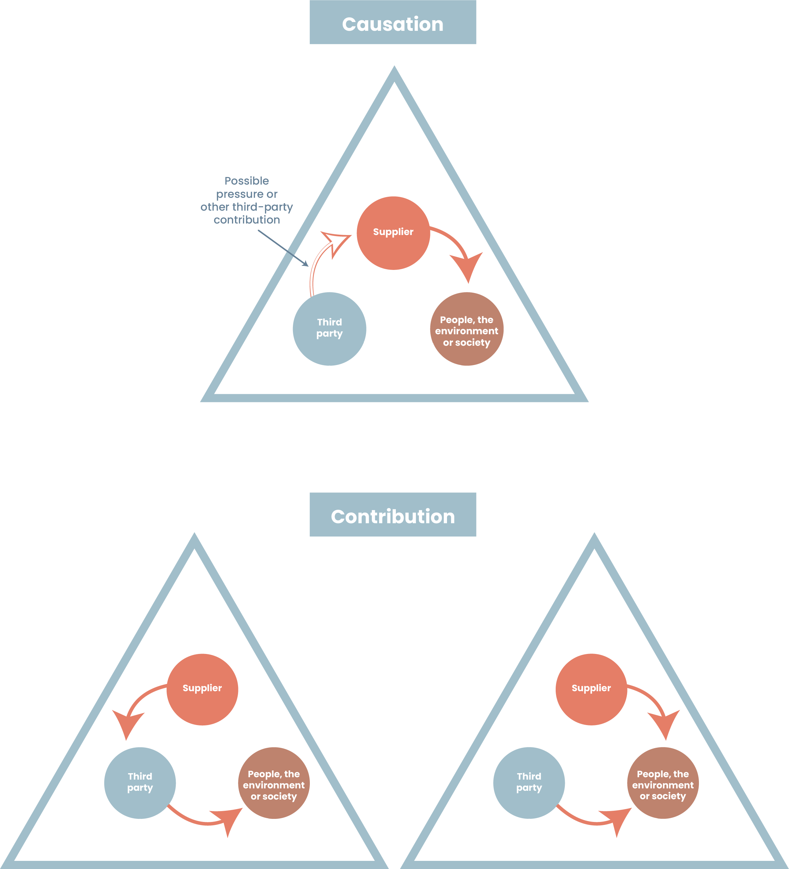
If the investigation team identifies that [Company] is linked to an actual adverse impact, the relevant Staff Function or Business Area shall use its leverage, to the extent practicable, to influence the entity causing the actual adverse impact to remedy it.
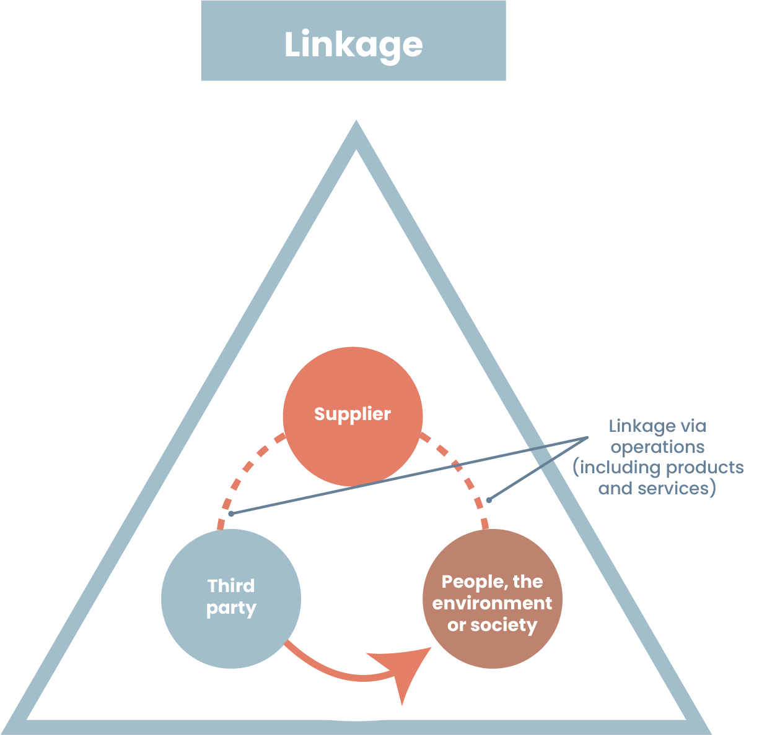

There is a continuum between contribution and linkage. A variety of factors can determine where on that continuum an adverse impact sits, including:
- the extent to which [Company] enabled, encouraged, or motivated the adverse impact
- the extent to which [Company] could or should have known about such adverse impact, and
- the quality of any mitigating steps [Company] has taken to address it.
7.2 Types of remedy
If [Company] has caused or contributed to an adverse impact, the relevant Staff Function or Business Area shall seek to restore the affected person(s) or environment to the situation they/it would be in had the adverse impact not occurred (where possible) and enable a remediation that is proportionate to the significance and scale of the adverse impact.
There are five types of remedy:
- apologies
- restitution or rehabilitation
- financial or non-financial compensation
- punitive sanctions
- measures to prevent future adverse impacts.
7.3 Determination of remedy
The type of remedy or combination of remedies that is appropriate will depend on the nature and extent of the adverse impact. The following may also be helpful in determining an appropriate remedy:
- Existing standards: In some cases, domestic and international standards or laws exist on what constitutes appropriate forms of remedy.
- Precedent: Where domestic and international standards do not exist, [Company] may seek to be consistent with what was provided in similar cases.
- Stakeholder preferences: The perspective of those affected on what is appropriate remedy is important for human rights impacts.
Vulnerable groups such as women, migrant workers and indigenous peoples may also have unique needs.
7.4 Rights-compatibility
The investigation team shall ensure that remedies are in line with internationally recognised human rights. Actions to enhance rights-compatibility include:
- Consulting affected stakeholders about the type of remedy needed and the way it should be delivered.
- Analysing remedies to ensure that they are adequate, effective, prompt, culturally appropriate and gender-sensitive, adjusting where necessary.
- Assessing proposals for the delivery of remedies to ensure they do not lead to further harms (for instance, by exacerbating community tensions).
- Evaluating the effectiveness of remedies and addressing any deficiencies.
- Having a plan to address the non-implementation of remedies.
7.5 Documentation
The investigation team shall develop a remediation plan that defines clear, expected results, which can be monitored and measured over time using quantitative and qualitative indicators.
The investigation team shall also document the remedy as such, including the rationale behind it.
The remediation plan and the documentation of remedy shall be stored and made available for later review, in case of legal proceedings.
7.6 Communication with complainant
The case manager shall engage meaningfully with affected stakeholders when adopting appropriate measures to remediate adverse impacts, including their implementation.
Complainant shall also be informed that they do not have to waive their access to state-based or other remedies, in order to receive the remedy.
The case manager shall base the communication on the default message in Annex B.
8. Implementing and monitoring the remediation
8.1 Follow-up
The investigation team shall implement and monitor the remediation plan. The investigation team may work with external partners, such as trade unions or civil society organisations, to conduct the follow-up.
8.2 Documentation
The investigation team shall document the implementation and the monitoring, including any payments provided to affected stakeholders.
The investigation team shall also document follow-ups with staff involved in the decision causing the complaint, to ensure the prevention of future adverse impacts.
The documentation shall be stored and made available for later review, in case of legal proceedings.
8.3 Communication with complainant
The case manager shall communicate with the complainant, including affected stakeholders, on the implementation and monitoring.
The aim shall be to confirm whether the remedy has in fact been fully provided and whether there have been any negative or positive consequences to the affected stakeholders.
The case manager shall base the communication on the default message in Annex B.
9. Closing the complaint
9.1 Assessment of satisfaction
The investigation team shall seek to assess the level of satisfaction of those who have raised complaints with the process provided and its outcome(s).
9.2 Communication with complainant
The case manager shall inform the complainant that the complaint has been closed and include a survey to assess the level of satisfaction.
The complainant shall also be provided with information on how to request a review of the decisions through [Company’s] [ombudsperson or similar function].
The case manager shall base the communication on the default message in Annex B.
9.3 Documentation
The investigation team shall draft a final report of the process and outcome(s), including:
- The date of the complaint.
- The date of closing of the complaint.
- The investigation team.
- A summary of the investigation, including any deferrals, mediation or arbitration.
- An assessment of whether timelines were kept, including regular updates to complainant.
- The conclusion of the investigation.
- A summary of the remedy provided to affected stakeholders (including the rationale behind it) adhering to privacy and confidentiality principles.
- The results of monitoring of remediation, to ensure its implementation.
- The stakeholders’ level of satisfaction with the process and the outcomes.
- A financial report that respects privacy principles.
The report shall be stored and made available for later review, in case of legal proceedings.
10. Incorporating feedback and evaluating results
10.1 Source of continuous learning
[Sustainability Department] shall ensure that the complaints procedure is a source of continuous learning for the prevention of future adverse impacts and for the improvement of the procedure itself.
10.1.1 Measure and analyse
[Sustainability Department] shall measure and analyse the frequency, patterns and causes of complaints. This to, inter alia, be able to:
- adapt policies and management systems to better manage risk
- more accurately identify and assess risks, including how impacts affect particularly vulnerable groups such as women, migrant workers or indigenous people
- improve preventive and mitigating measure
- contribute to wider discussions on sector-specific risks.
[Sustainability Department] shall also seek feedback from internal and external stakeholders on the performance of the complaints procedure.
10.1.2 Assess against effectiveness criteria
[Sustainability Department] shall yearly assess the effectiveness of the complaints procedure against the UN Guiding Principles eight effectiveness criteria.
Legitimate | Enabling trust from the stakeholder groups for whose use they are intended, and being accountable for the fair conduct of grievance processes.
Accessible | Being known to all stakeholder groups for whose use they are intended, and providing adequate assistance for those who may face particular barriers to access.
Predictable | Providing a clear and known procedure with an indicative time frame for each stage, and clarity on the types of process and outcome available and means of monitoring implementation.
Equitable | Seeking to ensure that aggrieved parties have reasonable access to sources of information, advice and expertise necessary to engage in a grievance process on fair, informed and respectful terms.
Transparent | Keeping parties to a grievance informed about its progress, and providing sufficient information about the mechanism’s performance to build confidence in its effectiveness and meet any public interest at stake.
Rights-compatible | Ensuring that outcomes and remedies accord with internationally recognized human rights.
A source of continuous learning | Drawing on relevant measures to identify lessons for improving the mechanism and preventing future grievances and harms.
Based on engagement and dialogue | Consulting the stakeholder groups for whose use they are intended on their design and performance, and focusing on dialogue as the means to address and resolve grievances.

10.2 Sustainability reporting
[Sustainability Department] shall yearly report on the complaints procedure’s results, performance and effectiveness in line with the Corporate Sustainability Reporting Directive and the European Sustainability Reporting Standards supplementing the directive.

Annex A: Decision tree
Is the reporting person/complainant one of the following?
- Worker employed by the company
- Self-employed individual at the company
- Shareholder or a member of the company’s administrative, management, or supervisory body, including non-executive members
- Volunteers or unpaid/paid trainees at the company
- Person under supervision of a contractor, subcontractor, or supplier to the company
- Individual reporting during recruitment or pre-contractual negotiations
- A facilitator, third person connected with the reporting person/complainant who could suffer retaliation in a work-related context (e.g. colleague or relative), or legal entity that the reporting person/complainant owns, works for or is otherwise with in a work-related context
Yes, apply the complaints procedure under the CSDDD
No, the complaint falls outside both directives. But you will still handle it.
Yes, apply the whistleblowing procedure due to the stronger retaliation protections provided under the Whistleblowing Directive
No
Yes
No, but you will still handle the complaint
No
Yes
Does the report/complaint address one of the following?
- Public procurement
- Financial services, products and markets, and prevention of money laundering and terrorist financing
- Product safety and compliance
- Transport safety
- Environmental protection
- Radiation protection and nuclear safety
- Food and feed safety
- Public health
- Consumer protection
- Privacy/data protection, and security of network and information systems
- Breaches affecting the financial interests of the Union as referred to in Article 325 TFEU
- Internal market rules as referred to in Article 26(2) TFEU, including taxation, competition, and state aid
Does the report/complaint address one of the following?
- The environment (climate change, pollution, water and marine resources, biodiversity and ecosystems, circular economy
- Own workforce (working conditions, equal treatment and opportunities for all, other work-related rights)
- Affected communities (economic, social and cultural rights, civil and political rights, rights of indigenous peoples)
- Consumers and end-users (information-related impacts, personal safety, social inclusion)
Is the reporting person/complainant one of the following?
- Natural or legal person who is affected or believe he/she/it could be affected by an adverse human rights or environmental impact
- Representatives of affected persons, for example civil society organisations, human rights defenders or workers’ representatives speaking on behalf of workers
- Environmental civil society organisations

Annex B: Default messages
Complaint received
Complaint founded [investigate further]
Complaint founded [deferral]
Complaint unfounded
Complaint update
Remediation of complaint
Implementation and monitoring of remediation
Closing of complaint

Complaint received
Thank you for reaching out to us.
We have received your complaint and will pass it on to the right team based on the issue and location.

What happens next?
Within 30 days, we’ll let you know if we find your concern founded or unfounded, and explain why. If we find it founded, we’ll share the next steps with you. The focus will be on arriving at a shared understanding of underlying problems and reaching agreed solutions. This means you may need to provide more information, but you can stay anonymous throughout the process if you communicate through this platform.
We typically involve representatives of the relevant staff function or business area in the process – unless there is a conflict of interest – as well as representatives from [add e.g. Legal Department] as needed. If third party expertise is brought into the process, we will communicate this with you.
If we caused or contributed to the harm, we will work with you to remediate it. The solution could involve an apology, restoration of the person to the situation he or she was in before the harm happened, rehabilitation of health or land, compensation, or measures to make sure it doesn’t happen again. If the harm was caused by someone else in our value chain, we’ll use our leverage to influence them to remediate it.
We aim to resolve issues within six months and will update you regularly. You can also request a follow-up at any time. In case of a severe harm, you have the right to meet with a [Company] representative to discuss the harm and possible remediation.
Click on the “Follow up” button in Speak up! for further communication with our team, including if you have any questions.

How do you know it’s safe?

Our Speak Up! service is run by an external partner to ensure your information stays safe, anonymous and confidential. All personal data is encrypted and protected.

If we need to share your information with the investigation team, authorities or other stakeholders we will do so without disclosing your identity – unless you agree to it. This is to keep you safe from any form of retaliation. [Company] employees or representatives who either disclose a complainant’s identity against their will or engages in any sort of retaliation towards a complainant will face disciplinary actions.

Need help during the process?

For independent advice during the process, contact [add email address, telephone number/ WhatsApp/ Signal to a civil society organisation or other stakeholder your Company enlists for this purpose].

If you need a lawyer, you can check out this directory:

- Business & Human Rights Resource Centre’s Lawyer Directory https://www.business-humanrights.org/en/big-issues/corporate-legal-accountability/lawyers-directory/

For information about global and national unions, visit these links:

- International Trade Union Confederation https://www.ituc-csi.org/?lang=en
- IndustriALL https://www.industriall-union.org/
- Building and Wood Workers’ International https://www.bwint.org/
- International Transport Workers’ federation https://www.itfglobal.org/en

Complaint founded [investigate further]
We have found your concern founded.
The reason for our decision is [add reason].
Since it is a severe and urgent matter, we have taken the following immediate actions:
- [add information]
- [add information]
We will now investigate the matter further.

What happens next?
Our focus is to arrive at a shared understanding of underlying problems and reaching agreed solutions.
We have involved representatives of [staff function(s) and/or business area] in the investigation. [We will also involve [third party expertise]. Do you have any objections or concerns related to this?]
We will furthermore engage [authority]/report the risk to [other stakeholder]. We will do this in a manner that does not endanger your safety, including by not disclosing your identity unless you agree to this.
To be able to investigate further, we would like the following information from you by [date]:
- [add information]
- [add information]
Please let us know if you need more time.
We also suggest a [digital] meeting on [date, time and place], if you are willing to meet.
We aim to resolve issues within six months of you filing the complaint and will update you regularly. You can also request a follow-up at any time. In case of a severe harm, you have the right to meet with a [Company] representative to discuss the harm and possible remediation.
Click on the “Follow up” button in Speak up! for further communication with our team, including if you have any questions.

How do you know it’s safe?
Our Speak Up! service is run by an external partner to ensure your information stays safe, anonymous and confidential. All personal data is encrypted and protected.
If we need to share your information with the investigation team, authorities or other stakeholders we will do so without disclosing your identity – unless you agree to it. This is to keep you safe from any form of retaliation. [Company] employees or representatives who either disclose a complainant’s identity against their will or engages in any sort of retaliation towards a complainant will face disciplinary actions.

Need help during the process?
For independent advice during the process, contact [add email address, telephone number/ WhatsApp/ Signal to a civil society organisation or other stakeholder your company enlists for this purpose].
If you need a lawyer, you can check out this directory:
- Business & Human Rights Resource Centre’s Lawyer Directory https://www.business-humanrights.org/en/big-issues/corporate-legal-accountability/lawyers-directory/

For information about global and national unions, visit these links:
- International Trade Union Confederation https://www.ituc-csi.org/?lang=en
- IndustriALL https://www.industriall-union.org/
- Building and Wood Workers’ International https://www.bwint.org/
- International Transport Workers’ federation https://www.itfglobal.org/en
Complaint founded [deferral]
We have found your concern founded.
The reason for our decision is [add reason].
Since there is currently [court process or some other state-based proceeding] under way, we defer to that process. We will support and cooperate in [court process or some other state-based proceeding].
However, since the complaint concerns a severe harm, you still have the right to meet with a [Company] representative to discuss the harm and possible remediation.
Click on the “Follow up” button in Speak up! for further communication with our team, including if you have any questions.

How do you know it’s safe?
Our Speak Up! service is run by an external partner to ensure your information stays safe, anonymous and confidential. All personal data is encrypted and protected.
If we need to share your information with the investigation team, authorities or other stakeholders we will do so without disclosing your identity – unless you agree to it. This is to keep you safe from any form of retaliation. [Company] employees or representatives who either disclose a complainant’s identity against their will or engages in any sort of retaliation towards a complainant will face disciplinary actions.

Complaint unfounded
We have found your concern unfounded, which means we will close the complaint.
The reason for our decision is [add reason].
- [add information]
- [add information]
I am available to discuss the decision during regular working hours at [add phone number].
You can also resubmit the complaint with additional information immediately or in the future.

Unhappy with the decision?
If you're not satisfied with our response, you can ask for a review by contacting one of our external ombudspersons [add link to external ombudspersons or similar function].
These ombudspersons are experienced lawyers who do not work for [Company]. They act in accordance with professional discretion.

Are there other ways to raise concerns?
If you’d rather use another avenue, you can reach out to these alternative mechanisms:

In our markets
[Add links to the following and similar authorities and organisations in your markets:
- Supervisory authority for substantiated concerns, once it has been established under the Corporate Sustainability Due Diligence Directive
- Relevant courts, including labour court
- OECD National Contact Point for Responsible Business Conduct
- Work environment authority
- Discrimination authority
- Environmental protection agencies
- Consumer protection authority
- Data protection authority
- National human rights institution
- Ombudsmen]

In other markets
- ILO Database on Occupational Safety and Health Agencies, Institutions and Organizations https://wwwex.ilo.org/dyn/interosh/f?p=14120:1:10173924926764:::::
- National Contact Points for Responsible Business Conduct https://mneguidelines.oecd.org/ncps/
- National human rights institutions https://ganhri.org/membership/
- European Court of Human Rights https://www.echr.coe.int/home
- Inter-American Court of Human Rights https://www.corteidh.or.cr/index.cfm?lang=en
- African Court on Human and Peoples’ Rights https://www.african-court.org/wpafc/
- UN Treaty Bodies https://www.ohchr.org/en/treaty-bodies
- Special Procedures of the Human Rights Council https://www.ohchr.org/en/special-procedures-human-rights-council

Multi-stakeholder initiatives
- International RBC Agreement for the Renewable Energy Sector https://www.imvoconvenanten.nl/en/renewable-energy/about-agreement/complaints-and-disputes
- [any other initiative you are a part of with a complaints procedure]

Where can you access counselling?
If you need a lawyer, you can check out this directory:
- Business & Human Rights Resource Centre’s Lawyer Directory https://www.business-humanrights.org/en/big-issues/corporate-legal-accountability/lawyers-directory/

For information about global and national unions, visit these links:
- International Trade Union Confederation https://www.ituc-csi.org/?lang=en
- IndustriALL https://www.industriall-union.org/
- Building and Wood Workers’ International https://www.bwint.org/
- International Transport Workers’ federation https://www.itfglobal.org/en

Complaint update
This is an update on your complaint.
Our focus is to arrive at a shared understanding of underlying problems and reaching agreed solutions.
So far, we have undertaken the following investigative measures:
- [add information]
- [add information]
We have attached [information obtained during the investigation]. Please provide your comments on [information obtained during the investigation] to us by [date]. Please let us know if you need more time.
We propose to initiate [mediation/arbitration], which is a form of alternative dispute resolution. [With mediation, the final decision is a reached agreement between [Company] and affected stakeholders. Any mediator should be freely accepted by both parties, and no party can be forced to accept a particular outcome. / In arbitration, an arbitrator analyses the case and reaches a verdict. For this, we suggest to use The Hague Rules on Business and Human Rights Arbitration]. ​Please provide your position on this proposal by [date].
We have furthermore decided to involve [third party expertise]. Do you have any objections or concerns related to this?
To be able to investigate further, we would like the following information from you by [date]:
- [add information]
- [add information]
Please let us know if you need more time.
We also suggest a [digital] meeting on [date, time and place], if you are willing to meet.
We aim to resolve issues within six months of you filing the complaint and will update you regularly. You can also request a follow-up at any time. In case of a severe harm, you have the right to meet with a [Company] representative to discuss the harm and possible remediation.
If you decide to withdraw from the process, which is your right, please let us know.
Click on the “Follow up” button in Speak up! for further communication with our team, including if you have any questions.

How do you know it’s safe?
Our Speak Up! service is run by an external partner to ensure your information stays safe, anonymous and confidential. All personal data is encrypted and protected.
If we need to share your information with the investigation team, authorities or other stakeholders we will do so without disclosing your identity – unless you agree to it. This is to keep you safe from any form of retaliation. [Company] employees or representatives who either disclose a complainant’s identity against their will or engages in any sort of retaliation towards a complainant will face disciplinary actions.

Remediation of complaint
We have completed the investigation and we want to apologise for [adverse impact] which we have [caused/contributed to through [action]].
We recognise that we have a responsibility for remediation.
We suggest to meet on [date, time and place] to discuss the following:
Remediation proposal
- [add information]
- [add information]
To be implemented and jointly monitored as follows:
- [add information]
- [add information]
Please let us know if you are able to meet at the suggested time. After the meeting, you will be given time to seek advice and propose adjustments.
You do not have to waive your access to state-based or other remedies, in order to receive this remedy.
Click on the “Follow up” button in Speak up! for further communication with our team, including if you have any questions.

How do you know it’s safe?
Our Speak Up! service is run by an external partner to ensure your information stays safe, anonymous and confidential. All personal data is encrypted and protected.
If we need to share your information with the investigation team, authorities or other stakeholders we will do so without disclosing your identity – unless you agree to it. This is to keep you safe from any form of retaliation. [Company] employees or representatives who either disclose a complainant’s identity against their will or engages in any sort of retaliation towards a complainant will face disciplinary actions.

Implementation and monitoring of remediation
In our opinion, the remedy has now been fully provided.
Can you confirm that this is the case?
Have there been any negative or positive consequences of the remediation?
Click on the "Follow up" button in Speak up! for further communication with our team, including if you have any questions.

How do you know it’s safe?
Our Speak Up! service is run by an external partner to ensure your information stays safe, anonymous and confidential. All personal data is encrypted and protected.
If we need to share your information with the investigation team, authorities or other stakeholders we will do so without disclosing your identity – unless you agree to it. This is to keep you safe from any form of retaliation. [Company] employees or representatives who either disclose a complainant’s identity against their will or engages in any sort of retaliation towards a complainant will face disciplinary actions.

Closing of complaint
We have now reached the closing of the complaint.
Your voice matters and we would like to thank you for cooperating with us. To ensure that we learn as much as possible, we would appreciate if you would answer a few questions on how satisfied you are with the process and the outcome(s). Your answers are anonymized and used in aggregate form, to improve our processes.
[add link to survey]

Unhappy with the decision?
If you're not satisfied with our response, you can ask for a review by contacting one of our external ombudspersons [add link to external ombudspersons or similar function].
These ombudspersons are experienced lawyers who do not work for [Company]. They act in accordance with professional discretion.

Are there other ways to raise concerns?
If you'd rather use another avenue, you can reach out to these alternative mechanisms:

In our markets
[Add links to the following and similar authorities and organisations in your markets:
- Supervisory authority for substantiated concerns, once it has been established under the Corporate Sustainability Due Diligence Directive
- Relevant courts, including labour court
- OECD National Contact Point for Responsible Business Conduct
- Work environment authority
- Discrimination authority
- Environmental protection agencies
- Consumer protection authority
- Data protection authority
- National human rights institution
- Ombudsmen]

In other markets
- ILO Database on Occupational Safety and Health Agencies, Institutions and Organizations https://wwwex.ilo.org/dyn/interosh/f?p=14120:1:10173924926764:::::
- National Contact Points for Responsible Business Conduct https://mneguidelines.oecd.org/ncps/
- National human rights institutions https://ganhri.org/membership/
- European Court of Human Rights https://www.echr.coe.int/home
- Inter-American Court of Human Rights https://www.corteidh.or.cr/index.cfm?lang=en
- African Court on Human and Peoples’ Rights https://www.african-court.org/wpafc/
- UN Treaty Bodies https://www.ohchr.org/en/treaty-bodies
- Special Procedures of the Human Rights Council https://www.ohchr.org/en/special-procedures-human-rights-council

Multi-stakeholder initiatives
- International RBC Agreement for the Renewable Energy Sector https://www.imvoconvenanten.nl/en/renewable-energy/about-agreement/complaints-and-disputes
- [any other initiative you are a part of with a complaints procedure]

Where can you access counselling?
If you need a lawyer, you can check out this directory:
- Business & Human Rights Resource Centre’s Lawyer Directory https://www.business-humanrights.org/en/big-issues/corporate-legal-accountability/lawyers-directory/

For information about global and national unions, visit these links:
- International Trade Union Confederation https://www.ituc-csi.org/?lang=en
- IndustriALL https://www.industriall-union.org/
- Building and Wood Workers’ International https://www.bwint.org/
- International Transport Workers’ federation https://www.itfglobal.org/en

